PLANTS DISEASE DETECTION USING CNN

# S.T.Santhanalakshmi, S.Rohini, M.Padmashree Associate Professor+, Students +

**+Department of Computer Science Engineering,**

**+Panimalar Engineering College, Chennai, Tamilnadu, India**

***Abstract*—Crop cultivation plays an essential role in the agricultural field. Presently, the loss of food is mainly due to infected crops, which reflexively reduces the production rate. To identify the plant diseases at an untimely phase is not yet explored. The main challenge is to reduce the usage of pesticides in the agricultural field and to increase the quality and quantity of the production rate. Proposed system explore the leaf disease prediction at an untimely action. The enhanced CNN algorithm to predict the infected area of the leaves. A color based segmentation model is defined to segment the infected region and placing it to its relevant classes. Experimental analyses were done on samples images in terms of time complexity and the area of infected region. Plant diseases can be detected by image processing technique. Disease detection involves steps like image acquisition, image pre-processing, image segmentation, feature extraction and classification.**

**Keywords— Infected crops, CNN algorithm, Image processing, Image acquisition, Image segmentation, Feature extraction**

**I.INTRODUCTION**

The primary occupation in India is agriculture. India ranks second in the agricultural output worldwide. Here in India, farmers cultivate a great diversity of crops. Various factors such as climatic conditions, soil conditions, various disease, etc. affect the production of the crops. The existing system can

Only identify the type of diseases which affects the leaf. It’s not efficient. Result will be provided within fraction of seconds and guided throughout the project.

In recent years, the rapid development of artificial intelligence has made life more convenient, and AI has become a well-known technology. For example, AlphaGo defeated the world champion of Go. Siri and Alexa as voice assistants of Apple and Amazon are all applications of artificial intelligence technology represented by deep learning in various fields. As the key research object of computer vision and artificial intelligence, image recognition has been greatly developed in recent years. In agricultural applications, the goal of image recognition is to identify and classify different types of pictures, and analyze the types of crops, disease types, severity and so on. Then we can formulate corresponding countermeasures to solve various problems in agricultural production in a timely and efficient manner. So as to further ensure and improve the yield of crops and help the better development of agriculture.

With the rapid development of deep learning, especially in image recognition, speech analysis, natural language processing and other fields, it shows the uniqueness and efficiency of deep learning. Compared with the traditional methods, deep learning is more efficient in the diagnosis of crop diseases in the field of agricultural production .The deep learning model can monitor, diagnose and prevent the growth of crops in time. Image recognition of crop diseases and insect

pests can reduce the dependence on plant protection technicians in agricultural production, so that farmers can solve the problem in time. Compared with artificial identification, the speed of intelligent network identification is much faster than that of manual detection. And the recognition accuracy is getting higher and higher in the continuous development. The establishment of a sound agricultural network and the combination of Internet and agricultural industry cannot only solve the problems related to crop yield affected by diseases and insect pests, but also be conducive to the development of agricultural informatization.

# II RELATED WORKS

The identification and prevention of crop diseases and insectpests is a continuous research topic. With the development of technology, many sensor networks and automatic monitoring systems have been proposed. A method of detection of specific disease in grapes is proposed. Downy mildew pest/disease can be detected by the real time system with weather data. The central sever provide forecast service of weather condition and disease. Another kind of solution related of monitoring traps which are used to capture pest is with the help of image sensors. The authors designed and implemented a low power consumed system which is based on wireless image sensors and powered by battery. The frequency of capturing and transferring trap images of sensors can be set and remote adjusted by trapping application. Acoustic sensors are also used in monitoring system. The authors give a solution to detect red palm we evil (abbr. RPW) with them. With the help of acoustic device sensor, the pest’s noise can be captured automatically. When the noise level of pest increases to some threshold, the system will notify the client that the infestation is occurring in the specific area. It helped farmers to be economical of time and energy to check every part of cropland by themselves and increase the labor efficiency. All acoustic sensors will be connected to base stations and each one will report the noise level if the predefined threshold value is surpassed

.Machine learning also had been applied in the agricultural

field, such as investigation of plant disease and pests and soon. Plenty of techniques of machine learning had been widely used to solve the problem of plant disease diagnosis. A Neural Network based method of estimating the health of potato with leaf image datasets is proposed. Additionally, the experimental research was carried out, which aimed to implement a system of recognizing plant disease with images. In order to distinguish wheat stripe rust from wheat leaf rust and grape downy mildew from powdery mildew, four different types of neural networks were trained based on color, shape and texture features extracted from disease image dataset. The work showed that neural network based on image processing can increase the effectively of diagnosing plant disease What’s more, scab disease of potato could be also detected by the image processing methods. Firstly, the images from various potato fields were collected. After image enhancement, image segmentation was carried out to acquire target region. At last, a histogram-based approach to analyses the target region was applied, so that the phase of the disease could be found.

# III CONVOLUTIONAL NEURALNETWORKS

# Deep neural network is gradually applied to the identification of crop diseases and insect pests. Deep neural network is designed by imitating the structure of biological neural network.

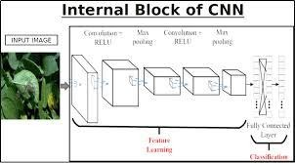

Convolutional neural network mainly solves the following two problems

* 1. **Problem of too many parameters:** It is assumed that the size of the input picture is 50 ∗ 50 ∗ 3. If placed in a fully connected feed forward network, there are 7500 mutually independent links to the hidden

layer. And each link also corresponds to its unique weight parameter. With the increase of the number of layers, the size of the parameters also increases significantly. On the one hand, it will easily lead to the occurrence of over-fitting phenomenon. On the other hand, the neural network is too complex, which will seriously affect the training efficiency. In convolutional neural networks, the parameter sharing mechanism makes the same parameters used in multiple functions of a model, and each element of the convolutional kernel will Acton a specific position of each local input. The neural network only needs to learn a set of parameters, and does not need to optimize learning for each parameter of each position.

* 1. **Image stability:** Image stability is the local invariant feature, which means that the natural image will not be affected by the scaling, translation and rotation of the image size. Because in deep learning, data enhancement is generally needed to improve performance, and fully connected feed forward neural is difficult to ensure the local invariance of the image. This problem can be solved by convolution operation in convolutional neural network.

At present, the typical convolutional neural networks widely used are as follows.

* + 1. **LeNet-5**: Although proposed very early, butLeNet-5 is a complete and successful neural network, especially in handwritten numeral recognition system applications. The LeNet-5 network has seven layers, including two convolution layers, two convergence layers (also called pooling layers), and three full connection layers. The **input image size is 32 ∗ 32, and the output** corresponds to 10 categories.
    2. **Alex Net**: Alex Net consists of five convolution layers, three convergence layers and three full connection layers. Alex Net absorbs the idea and principle of LeNet-5 network, and also makes many innovations.

These include using the ReLU function instead of the sigmoid function to solve the gradient dispersion problem. Dropout is used at the fully connected level to avoid over fitting.

* + 1. **Inception Network**: Inception is different from the general convolution neural network in that it contains multiple convolution kernels of different sizes in its convolution layer, and the output of Inception is the depth stitching of the feature map. Google Net, the winner of the 2014 Image Net Image Classification Competition, is the earliest version of Inception v1 used
    2. **Residual network**: The core idea of residual network is to make a non-linear element composed of neural networks infinitely approximate the original objective function or residual function by using the general approximation theorem. Many nonlinear elements form a very deep network, which is called residual network.

# VII PROPOSED SYSTEM

Plant diseases are detected and the solutions to recover from the leaf diseases will be provided. The affected part of the leaf is shown by image processing technique. The database is preprocessed such as Image reshaping, resizing and conversion to an array form. Similar processing is also done on the test image. The train database is used to train the model (CNN) so that it can identify the test image and the disease it has .CNN has different layers that are Dense, Dropout, Activation, Flatten, Convolution2D, and MaxPooling2D. After the model is trained successfully, the software can identify the disease if the plant species is contained in the database. After successful training and preprocessing, comparison of the test image and trained model takes place to predict the disease.

**MODULE 1: IMAGE ACQUISITION**

The initial process is to collect the data from the public repository. It takes the image as input for

further processing. Popular image domains are taken so that any formats can be given as input to the process (.bmp, .jpg, .gif).The main goal is to detect and recognize the class disease in the image. To adapt it with different feature extractors that detects diseases in the image.

**MODULE 2: IMAGE PREPROCESSING**

As the images are acquired from the real field it may contain dust, spores and water spots as noise. The purpose of data preprocessing is to eliminate the noise in the image, so as to adjust the pixel values. It enhances the quality of the image.

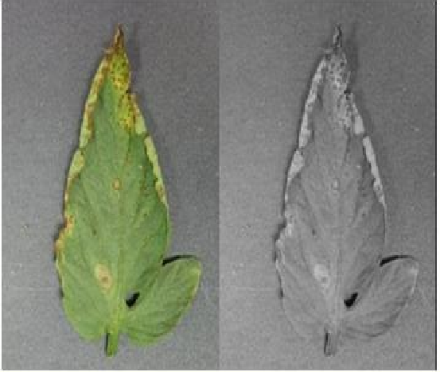

**MODULE 3: IMAGE SEGMENTATION**

Image segmentation is the third step in the proposed method. The segmented images are clustered into different sectors using Otsu classifier and k-mean clustering algorithm. Before clustering the images, the RGB color model is transformed into Lab color model. The advent of Lab color model is to easily cluster the segmented images**.**

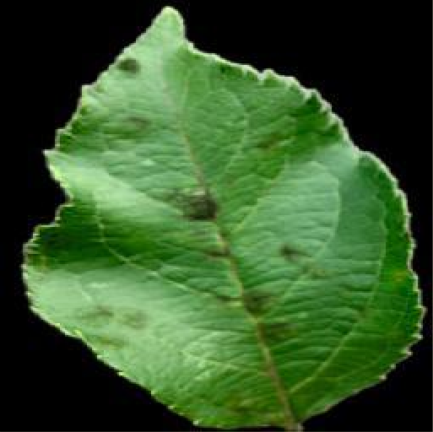

**MODULE 4: FEATURE EXTRACTION**

Feature extraction is the important part to gracefully predict the infected region. Here shape and textural feature extraction is done. The shape oriented feature extraction like Area, Color axis length, eccentricity, solidity and perimeter are calculated. Similarly the texture oriented feature extraction like contrast, correlation, energy, homogeneity and mean is captured and processed to determine the health of each plant. There are some conditions that should be taken into consideration when choosing a Feature Extractor, such as the type of layers, as a higher number of parameters increases the complexity of the system and directly influences the speed, and results of the system. Although each network has been designed with specific characteristics, all share the same goal, which is to increase accuracy while reducing computational complexity. In this system each object detector to be merged with some of the feature extractor.

**FLOW DIAGRAM**

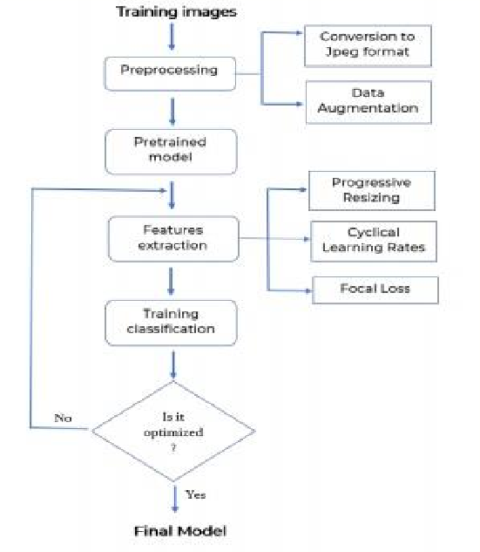

**CONCLUSION**

In this paper, 38 Categories of plant diseases were studied. The VGG 16 model is constructed by using deep learning theory and convolution neural network technology. Experiments show that the model can effectively identify the data set, and the overall recognition accuracy is as high as 95%. It can be effectively applied to the identification and detection of plant diseases.

**REFERENCES**

[1] K. Padmavathi, and K. Thangadurai,

“Implementation of RGB and Gray scale images in plant leaves disease detection –comparative study,” Indian J. of Sci .Tech .,vol 9,pp.1-6 ,Feb .2016

[2] Kiran R. Gavhale, and U. Gawande, “An Overview of the Research on Plant Leaves International Journal of Pure and Applied Mathematics Special Issue 882 Disease detection using Image Processing Techniques

Android Phone,” J. of Infor. & Compu. Sci., vol. 12, pp. 6845-6852, Dec. 2015.

[4]Wenjiang Huang, Qingsong Guan, JuhuaLuo, Jingcheng Zhang, Jinling Zhao, Dong Liang,

Linsheng Huang, and Dongyan Zhang, “New Optimized Spectral Indices for Identifying and Monitoring Winter Wheat Diseases”, IEEE journal of selected topics in applied earth observation and remote sensing,Vol. 7, No. 6, June 2014

[5] Monica Jhuria, Ashwani Kumar, and

RushikeshBorse, “Image Processing For Smart Farming: Detection Of Disease And Fruit Grading”, Proceedings of the 2013 IEEE Second International Conference on Image Information Processing (ICIIP-2013)

[7] Mrunalini R. Badnakhe Prashant R.

Deshmukh, Comparison Clustering”,

“Infected Leaf

by Otsu Threshold International Journal

Analysis and

Research in Computer Science

and k-Means of Advanced and Software

Engineering, Volume 2, Issue 3, March 2012.

[6] Zulkifli Bin Husin, Abdul Hallis Bin Abdul Aziz, Ali Yeon Bin MdShakaffRohaniBinti S Mohamed Farook, “Feasibility Study on Plant Chili Disease Detection Using Image Processing Techniques”, 2012 Third International Conference on Intelligent Systems Modelling and Simulation.

[8] H. Al-Hiary, S. Bani-Ahmad, M. Reyalat, M.

Braik and Z. ALRahamne, h “Fast and Accurate Detection and Classification of Plant Diseases”, International Journal of Computer Applications (0975 – 8887) Volume 17– No.1, March 2011

[3] Y. Q. Xia, Y. Li, and C. Li, “Intelligent Diagnose System of Wheat Diseases Based on